**Tumblr Lesson 1 Instructions**

Step 1: Have the students watch the CSS videos that we have done - they’re all in a youtube playlist:

Step 2: Have students set up tumblr accounts.

Step 3: Have students log in to their email account and confirm with Tumblr.

Step 3: Have them fill out their blog information (don’t spend long on this step):

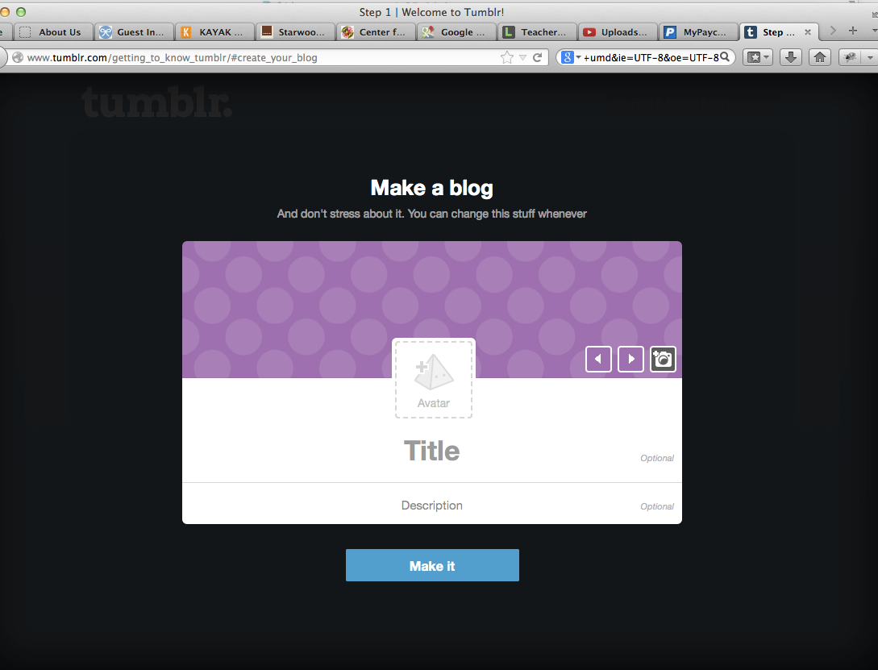

Step 4: Have students follow the first 3 blogs they see (this part doesn’t matter):

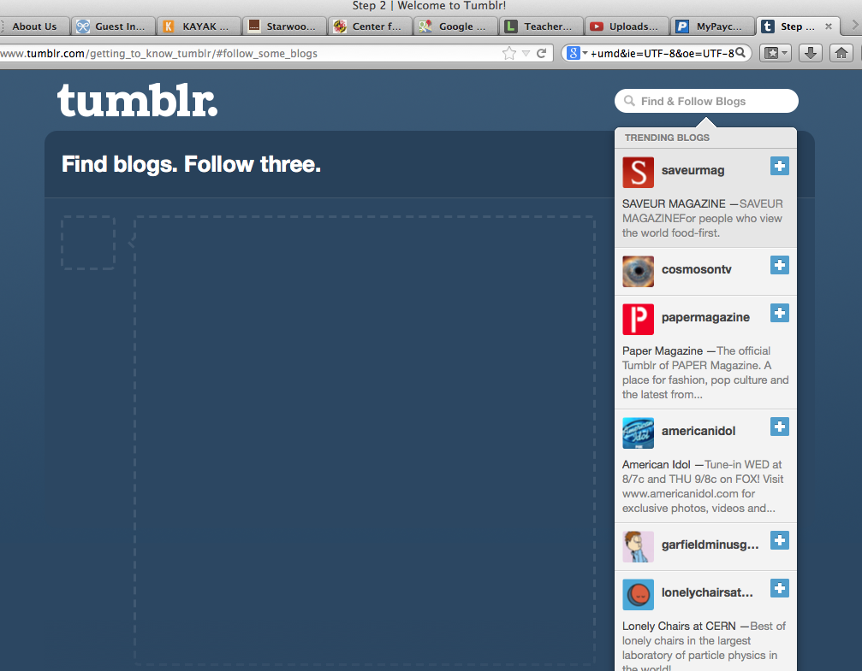

Step 5: Click “I’ll get it later” when they are asked about getting the app: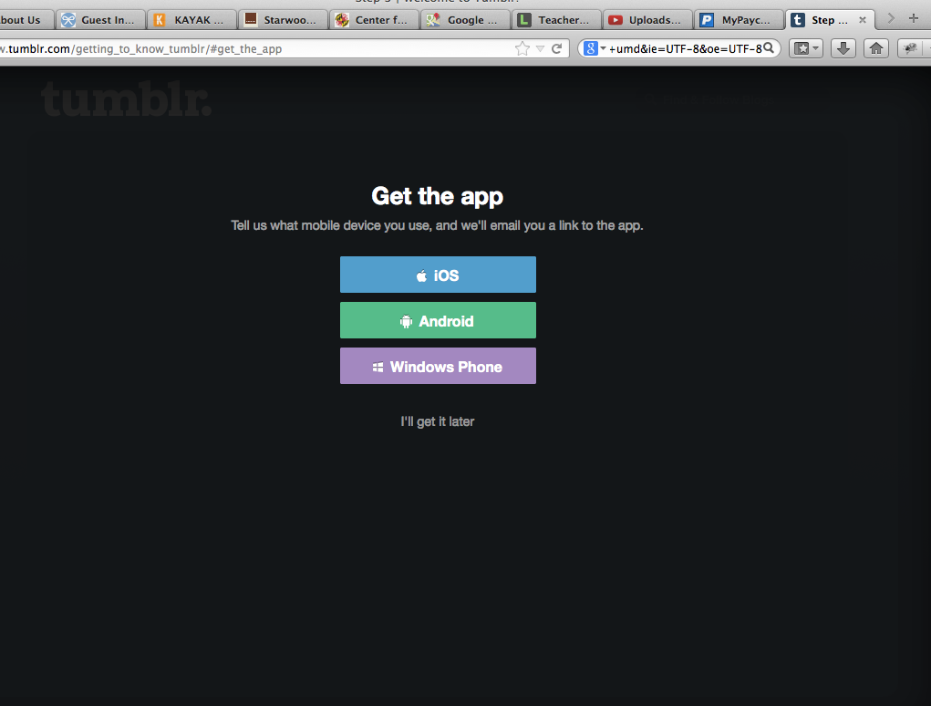

Step 6: Click customize on the right panel:  
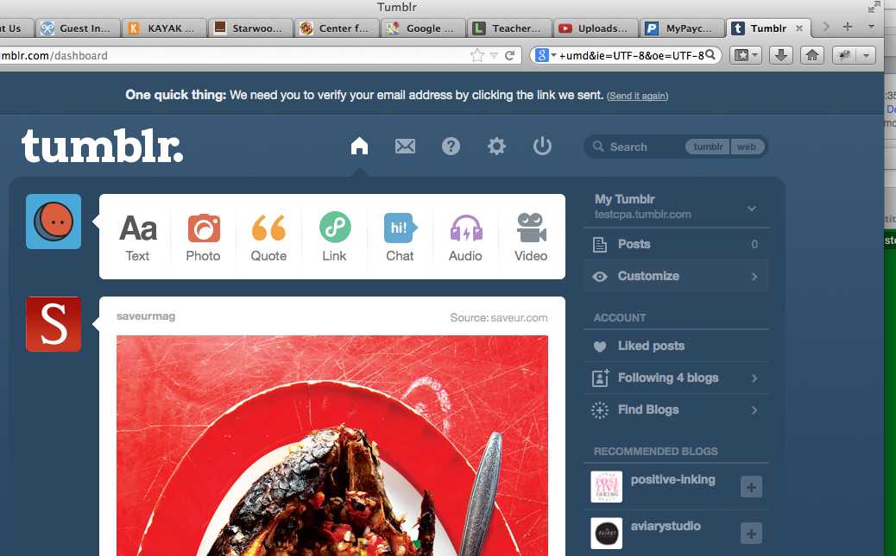

Step 7: Click “Edit HTML”

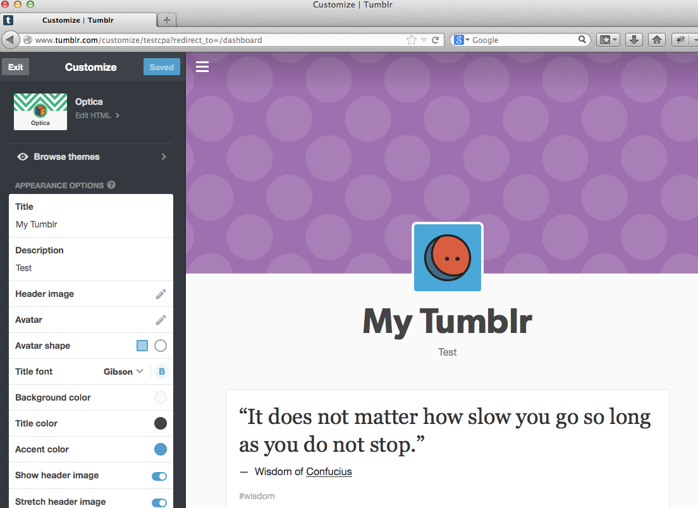

Step 8: Have students do Ctrl-A to select all of the HTML and have them replace it with the code contained in mcwic.github.io/htmlblocks/tumblrTheme.html

Step 9: Have students try to change the background color on the page. They will need to go to lines 31-39 (see if they can find the right section themselves):

body {

margin: 0;

padding: 20px;

**background-color: green;**

font-family: arial;

font-size: 0.75em;

color: blue;

}

Step 10: Have them click “Update Preview” and “Save”

Step 11: Have them go back to tumblr.com and have them reblog a few posts.

Step 12: After they have rebloged 3 posts, have them return to the html editor.

Step 13: Have students try to change the font color of the links. The color of the links and the color of the link background during hover, and the color of the link after it is clicked. This should involve changing some of the code between lines 40 -52. The relevant sections are bolded and commented below.

body {

margin: 0;

padding: 20px;

background-color: green;

font-family: arial;

font-size: 0.75em;

color: red;

}

**a { //this is the link as it is normally**

**color: black;**

text-decoration: underline;

}

**a:hover {** **//this is the link when the mouse is hovering**

**color: white;**

**background: red;**

}

**a:visited**{ **//this is the link after it is visited**

color:blue;

}

Step 14: Have students try to change the size of images or add a border to images (they will need to search w3 to find how to add a border or you can give them this url: <http://www.w3schools.com/css/css_border.asp>). They should modify the Tumblr code on lines 54-59.

**img {**

max-width: 100%;

**}**

They will need to add code such as the following:

**border-width: 10px;**

**border-color: white;**

**border-style: solid;**

Step 15: Encourage students to keep scrolling through the CSS and changing things on their Tumblr page. Keep them OFF the main Tumblr site.